Classified, Administrators/
Confidential Staff
Packet

Guidelines for Professional Development Requests

Office of Human Resources, Training & Development
Room 1544

Christina Rivera
Training and Development Manager
(707) 256-7107
crivera@napavalley.edu

Overview of Process in Four Quick Steps!
Purpose
Colleges with strong and supportive professional development programs demonstrate an increase in student retention and performance and overall student success. Napa Valley College is committed to supporting and encouraging the improvement of leadership, job training, teaching and learning and includes professional development as part of its Strategic Plan and institutional mission.
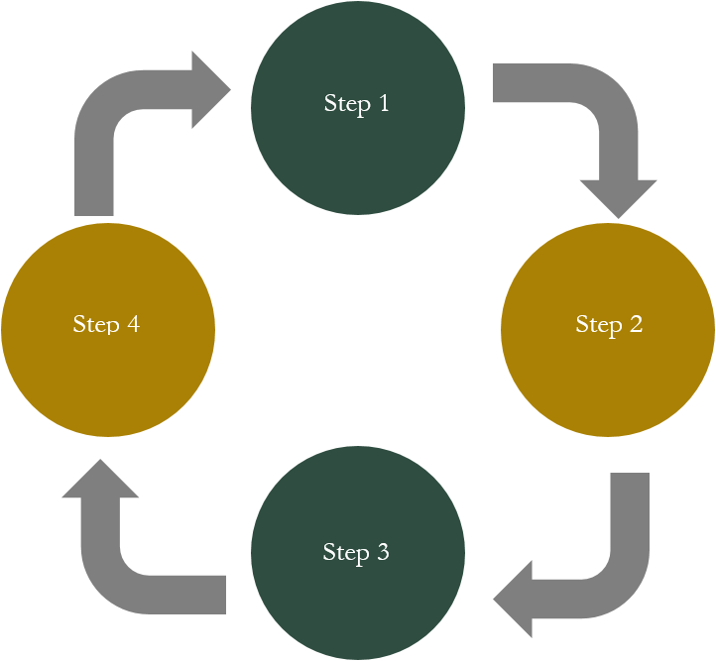

Overview of Process

Step 1: Cabinet Meets – Summer Session
The Cabinet meets to discuss professional development allocation and process for the academic year that meets the training goals of various grants, initiatives, foundation and other funding sources related to training and professional growth.

Step 2: Department Supervisors are Trained – Summer Session
Department supervisors are cross-trained on, 1) goals of funding sources, 2) available funding and 3) process for staff to apply for funding.

Step 3: Department Meets throughout Year
Department supervisors lead professional development discussions and determine goals and activities related to their unique focus and needs. Established activities benefit individual staff members and/or the institution as a whole. Departments share goals with their staff.
Step 4: Individual Staff Request Funding
Individuals may request funding throughout the academic year. All requests are signed by the dean and department supervisor and submitted to the Office of Human Resources (HR).
Quick Directions to Submit for
Professional Development Activity

Individual Activity (i.e., conference, lecture, course, observation)

- Complete the Professional Development Activity form.

- Submit the completed form with the appropriate signatures and conference literature, course information etc. to Christina Rivera, Training and Development Manager, in room 1544F, at least forty-five (45) days prior to the date of the event.

- Include all estimated expenses for the training.

Notes:
- If an advance to pay for expenses is needed, please submit at least sixty (60) days prior to date of the event to allow for processing.
- Out-of-state travel needs the approval of the college president.
- Completing the Travel/Conference Expense Approval form will assist with coming up with an estimated cost for the Professional Development Activity form.
- Should a request come in three weeks or less prior to the activity, please note that approval process may not be made in time for the Business Office to cut a check. If you have any questions, please contact Christina Rivera at 256-7107.

- Criteria for approving professional development request is on page 5.

- Information on what happens next is on page 6.

Examples

Individual Request:
Staff work with the supervisor to determine individualized professional development goals. Examples include:
- Conferences
- Site visits to other campuses, area schools, agencies, facilities, etc. for observations, demonstrations, professional development conversations, etc.
- Attending needed workshop or training, etc.

Professional Development Activity (EXAMPLE)

Use this form for pre-approval for a professional development activity. Please review professional development guidelines and timeline.

Name Herman Munster Division/Department A&R____

Contact Information hmunster@napavalley.edu; (w) 707-222-1313 (c) 707-777-7777
Email, Phone Number and Cell Phone Number

Date of Activity October 29, 2017 Amount of Funding Requested $700____________

Type of activity, please mark one:

X Individual activity you plan to attend in the future (i.e., conference, lecture, course, observation)
Note: If an advance to pay for expenses is needed, please submit up to sixty (60) days prior to date of the event to allow for processing.
□ Division or department group activity/project/presenter
Note: If the activity requires outside speaker or workshop presenter, the division/department designee will need to submit paperwork up to ninety (90) days prior to the event to enable an independent contract to be processed.
□ Flex day presenter (estimate number of hours _______________)
□ Other: ________________________________________________________________________

Descriptions: (For both descriptions, you may attach a separate sheet.)
Brief description of activity

Attend Annual CACCRAO conference on the latest state mandates that affect admission requirements.

Relevance to the strategic plan initiatives, Student Equity, or department’s goals, and teaching assignment.

The conference is related to addressing the goals of Guided Pathways and Student Success Center model.

Before turning in your proposal, please obtain your supervisor’s approval.

Supervisor _________________________________________________ Date ____________
Criteria for Approving Professional Development Funding
Classified and Administrators/Confidential Staff

Professional development funding is available in support of enrichment activities that support the mission of the college. Those individuals seeking professional development have an opportunity to request funding for activities in those areas they need support in within their professional roles at NVC. All are encouraged to apply for funds as outlined per the following criteria:

Individual Activity Requests
- Individual applicants for this process include classified and administrators/confidential staff.
- Conference attendees/trainees may be asked to participate in on-campus training opportunities or to share what they have learned with others across campus.

Note: For group or department activity, it is recommended that requests are included in the unit plan.

Funding and Conference Limits
- During the academic year, there may be a limit as to how many conferences an individual can attend in one year; overall training costs are considered for each request.
- Out-of-state travel: Requesting to attend a single out-of-state conference is limited to full-time employees and a team (3 or 4 maximum) will be considered for a single out-of-state conference. The President must approve out-of-state travel.

Activity Approval
- Activities must have a demonstrable impact on students and/or staff at NVC.
- Individuals will be funded based on direct training benefits for the individual’s specific role at the college and the NVC strategic plan.
- Conferences that are not endorsed by the employee’s supervisor will not be funded.

Next Steps in the Approval Process

After Submitting Request Form, What Happens Next?

- The completed hardcopy of the Professional Development Activity forms are turned into the Office of Human Resources, Training & Development Manager, Christina Rivera.

- The Professional Development Team reviews proposals weekly. These individuals are part of the District’s Staff Development Committee. Note: The Professional Development Team is listed on page 8.

- The team recommends and distributes professional development requests to appropriate funding sources for final approval.

- Priority will be given to proposals that meet the college’s Strategic Plan initiatives; goals of the Student Equity plan, foundation and other funding sources; and to those that submit completed requests.

- Notification of the status of requests is within two to three weeks after submitting the request.

- Individual staff will be notified of approval/denial by email from Christina Rivera (see next page for example approval email).
Professional Development Notification
Example Approval Email

Congratulations on your approved professional development request to attend a conference in San Diego, June 11 to June 15, 2019 (total amount $2,500). Below are next steps to complete the paperwork for approval to travel and steps to complete paperwork after you travel. Office assistants in your department can assist with your registration and travel accommodations.
Items to complete prior to your conference (check off steps):
□ Please submit your request on the Travel/Conference Expense Approval form and have your dean sign the form. Here is a link to the new travel forms: http://www.napavalley.edu/businessfinance/Pages/travreimbinfofms.aspx
□ Attach flyer or brochure about your conference and support for estimated mileage, meals, tolls, and parking.
□ If you need an advance, make sure you mark this on your form. Please note that the Business Office needs a minimum of two weeks advance notice and can only advance up to 85% of estimated mileage, meals, parking, and tolls.
□ After you have the required signature and documentation, please send the form to me; and I will work with the dean of the funding source to code and sign travel form. Please do not send your travel electronically to me. My office is in the library, room 1771 (TLC), and I have a mailbox on the ground floor if I am not in my office.
□ Once the forms have all of the appropriate signatures, the form will be forwarded to the Business Office. A scanned copy of the original approved form with all signatures will be emailed to the applicant for support to include with travel voucher and/or credit card logs. Please note if you have questions about your travel advance, you will need to check with the Business Office once you receive the scanned copy (this scanned copy is also needed for the next steps below).
Items to complete after your conference:
□ Once you come back from your trip, a travel conference voucher must be filled out, signed by your supervisor and attach it to your approved travel form. Please attach all receipts to the voucher, the final approved Travel/Conference Expense Approval form (with Controller’s signature) and send it directly to me. Make sure you download the new voucher form from the Business and Finance Office website. Here is the link: http://www.napavalley.edu/businessfinance/Pages/travreimbinfofms.aspx
Please do not send your travel electronically to me.

Professional Development Teams

The Professional Development teams will consist of the two or members from the Staff Development Committee below.

Staff Development Committee composition:
- Associate Vice President, Human Resources and Training & Development and Title IX Coordinator (Co-Chair)
- Professional Development Faculty Coordinator(Co-Chair)
- Training and Development Manager
- 1 Representatives from the Academic Senate Professional Development Committee
- 1 Representative from the Administrative Senate
- 1 Representative from the Classified Senate
- ASNVC, Student Representative

Funding Source Approvers:
Assistant Superintendent/Vice President, Academic Affairs (as needed)
Assistant Superintendent/Vice President, Student Affairs (as needed)
Dean, Counseling Services & Student Success (SSSP as needed)
Director, Equity and Inclusivity (SE as needed)
Managing Director of the Foundations (as needed)
Administrators and/or faculty responsible for other funding sources (as needed)
Associate Vice President, Human Resources and Training & Development and Title IX Coordinator (as needed)

